Department | AIDS
Course Code / Course Name | DSA0602/ Data Handling and Visualization
Experiment | Data Visualization using R
Name | Ayesha Siddiqa S
Register Number | 192324305
Date | 10/10/2026
Day | Saturday
SET 16 Customer Demographics Analysis

1. Bar chart — Distribution of customer ages
Aim: To visualize the age distribution of customers using a bar chart.
Algorithm:
- Create a data frame containing customer ID, age, gender, and income.
- Load the ggplot2 library.
- Map customer age to the x-axis and frequency to the y-axis.
- Add a title, axis labels, and a suitable theme.
- Display the bar chart.
Code:
# Install and load library
if (!requireNamespace("ggplot2", quietly = TRUE))
install.packages("ggplot2", type = "binary")
library(ggplot2)

# Create dataset
customers <- data.frame(
ID = c(1, 2, 3),
Age = c(28, 35, 42),
Gender = c("Female", "Male", "Female"),
Income = c(50000, 60000, 75000)
)

# Create bar chart
ggplot(customers, aes(x = factor(Age))) +
geom_bar(fill = "skyblue") +
labs(title = "Distribution of Customer Ages",
x = "Age (years)", y = "Number of Customers") +
theme_minimal()
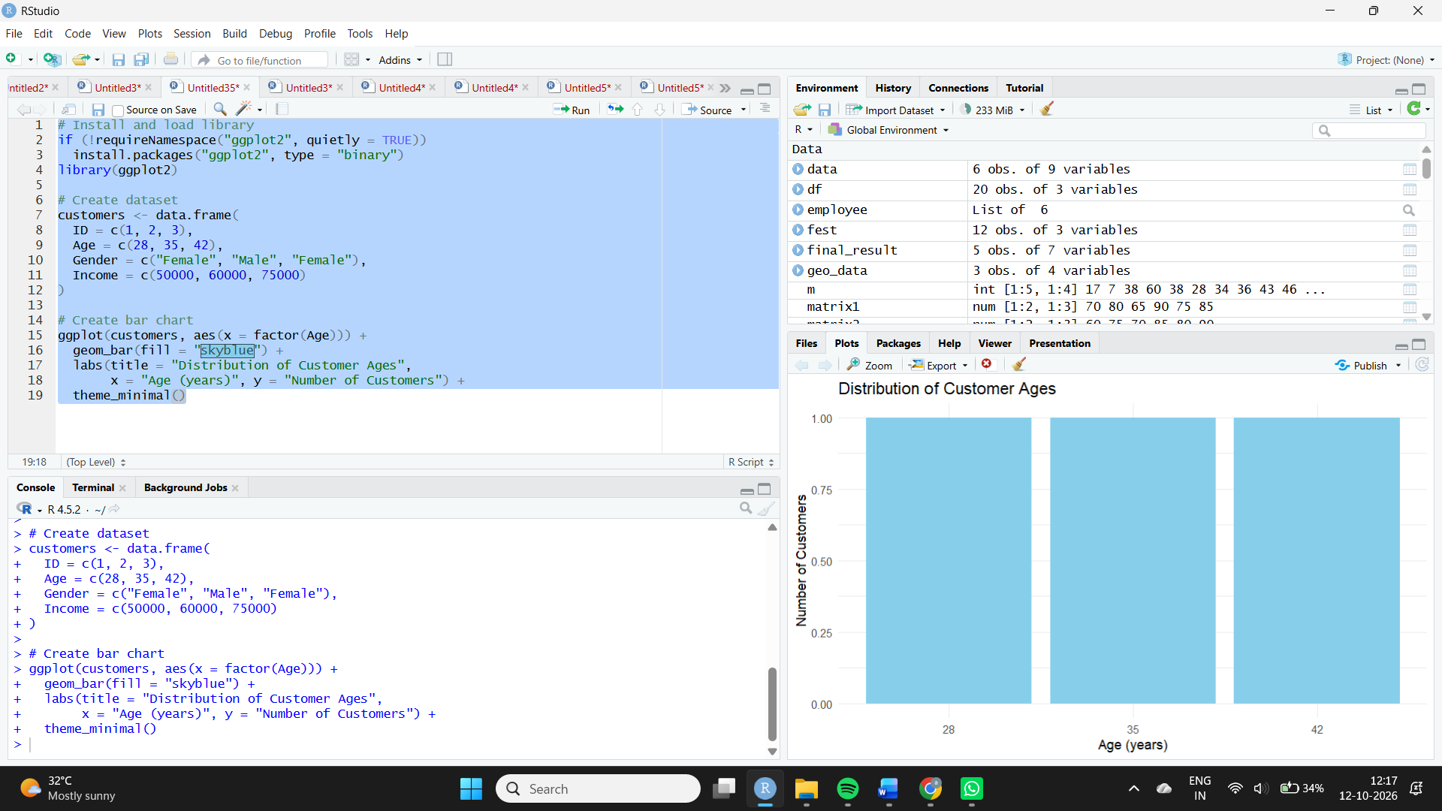
Observation: The three customers are aged 28, 35, and 42 years, with one customer in each age group.
2. Pie chart — Customer gender distribution
Aim: To represent the proportion of male and female customers using a pie chart.
Algorithm:
- Create the customer demographic data.
- Count customers in each gender category.
- Calculate the percentage for each category.
- Draw a pie chart with labels and a legend.

Code:
library(ggplot2)

gender_data <- as.data.frame(table(customers$Gender))
names(gender_data) <- c("Gender", "Count")
gender_data$Percent <- gender_data$Count / sum(gender_data$Count) * 100
gender_data$Label <- paste0(gender_data$Gender, " (",
gender_data$Percent, "%)")

ggplot(gender_data, aes(x = "", y = Count, fill = Gender)) +
geom_col(width = 1) +
coord_polar(theta = "y") +
geom_text(aes(label = Label),
position = position_stack(vjust = 0.5)) +
labs(title = "Customer Gender Distribution", fill = "Gender") +
theme_void()
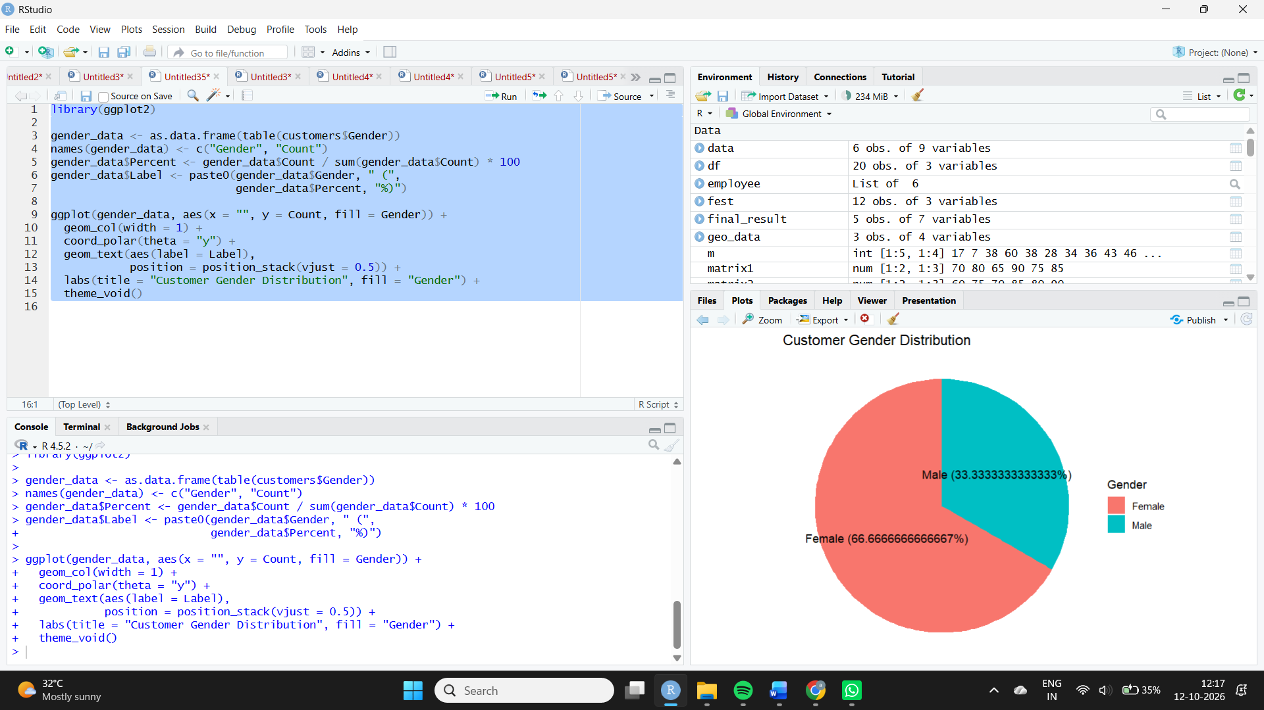
Observation: Female customers account for 66.67% of the dataset, while male customers account for 33.33%.
3. Demographic table
Aim: To display customer demographic details in a structured table.
Algorithm:
- Create the customer data frame.
- Assign clear column headings.
- Display all customer records.
Code:
print(customers)

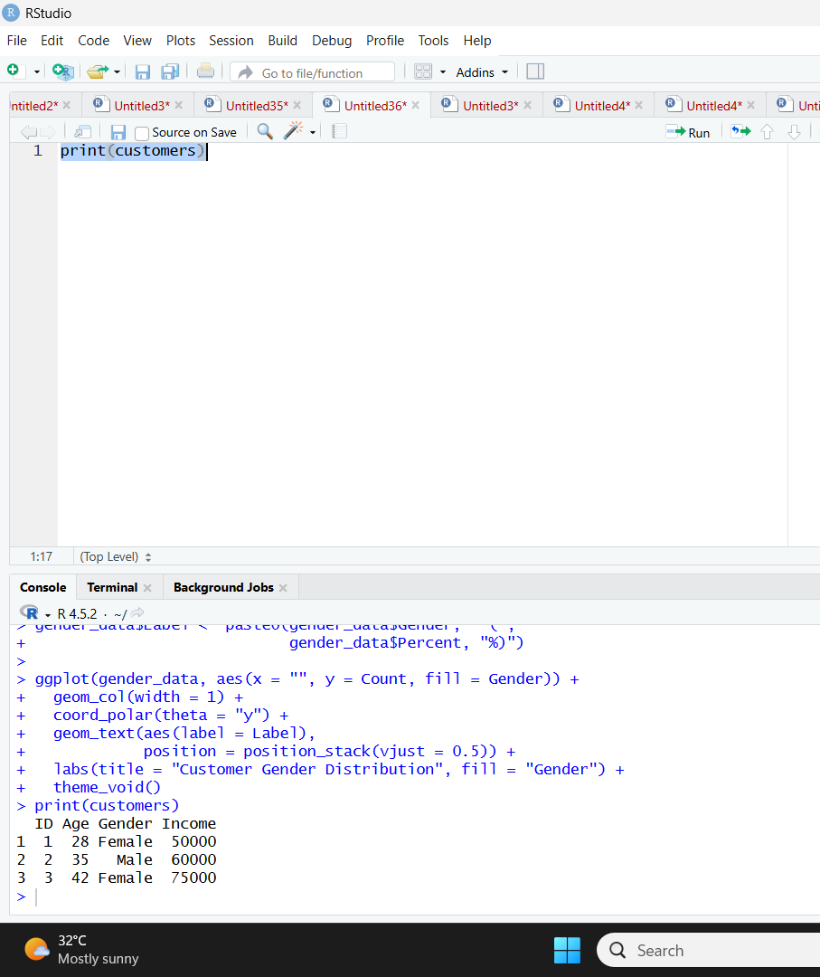
Observation: The table displays the ID, age, gender, and income of all three customers. Customer 3 has the highest income of $75,000.
4. Tableau dashboard
Aim: To combine the age chart, gender pie chart, and demographic table into an interactive dashboard.
Algorithm:
- Connect Tableau to the customer dataset.
- Create an age bar chart.
- Create a gender pie chart.
- Create a demographic table.
- Combine all three worksheets in a dashboard.
- Add filters and configure dashboard actions.
Procedure in Tableau:
- Open Tableau and connect to an Excel or CSV file containing the customer data.
- For the age chart, drag Age to Columns and Customer ID to Rows; change the aggregation to Count.
- For the gender pie chart, select Pie in the Marks card, place Gender on Color and Customer ID on Angle, using Count.
- For the table, place Customer ID, Age, Gender, and Income on Rows or Text.
- Create a new Dashboard and drag all three worksheets into it.
- Add a Gender filter or configure Use as Filter on the charts.
Observation: The dashboard combines demographic charts and detailed records, enabling users to explore the customer distribution interactively.

